*Assignment 4*

*Instructor: Faisal Khan*

|  |  |  |
| --- | --- | --- |
| *Name* | *Student ID* | *Group#* |
| Neelesh Maharjan | C0838743 |  |
| Anila Sunny | C0842969 |  |
| Anupriya Haridas | C0860514 |  |
| Abhishek Arora | C0837189 |  |
| Arman Rohaj | C0860916 |  |

1-Use Documentation Comments where needed and use Javadoc to create HTML files for documentation.

2-In your project src folder add this word document with all your group members names and paste the screen shots of your output after each question.

2-Right Click on your Project Folder in Eclipse, Copy Option is available. Create a copy of the Project and upload the zipped folder using Moodle.

Create a web based application using JSPs & Servlets.Your

web application should maintain username and password using

all the four tricks available for session Tracking.

You should be able to perform all these Operations.

a)Create a coloured Login page for your application. 20

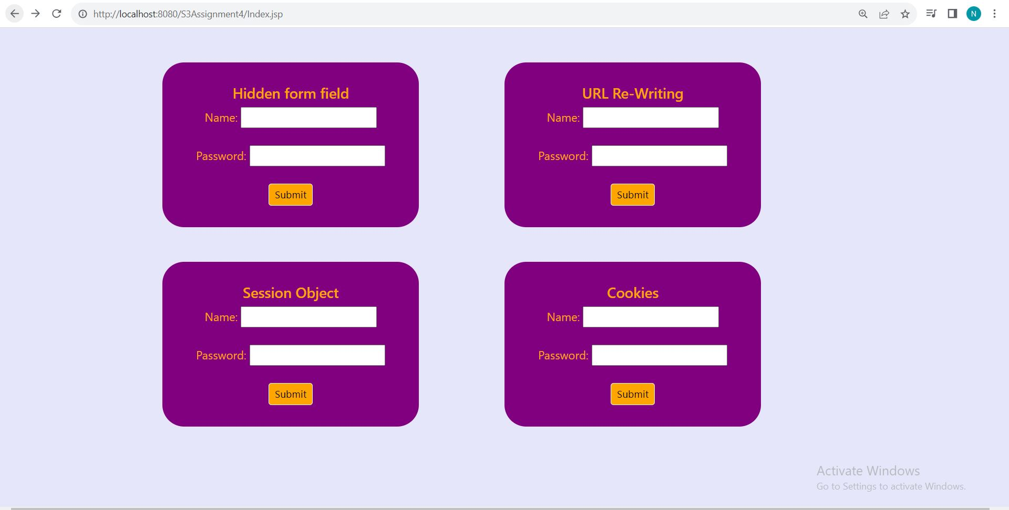

b) Display a success message on a new Page with the user name maintained in session using Cookies. 20

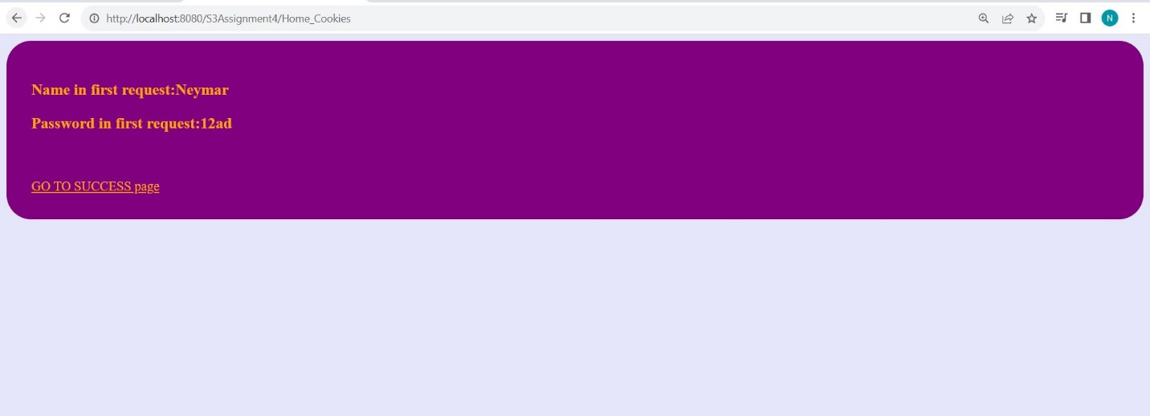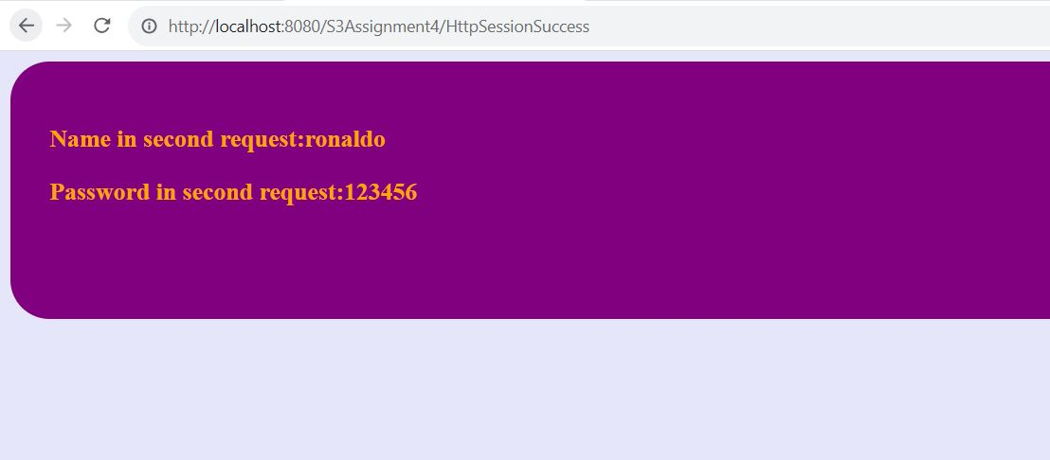

c) Display a success message on a new Page with the user name maintained in session using Hidden Form Field. 20

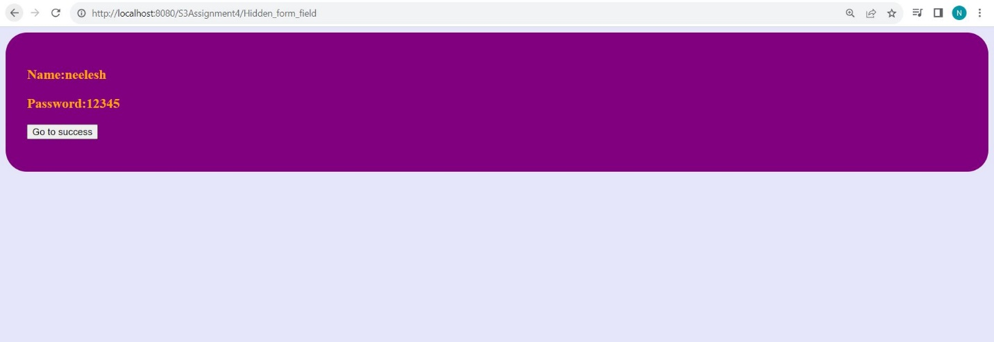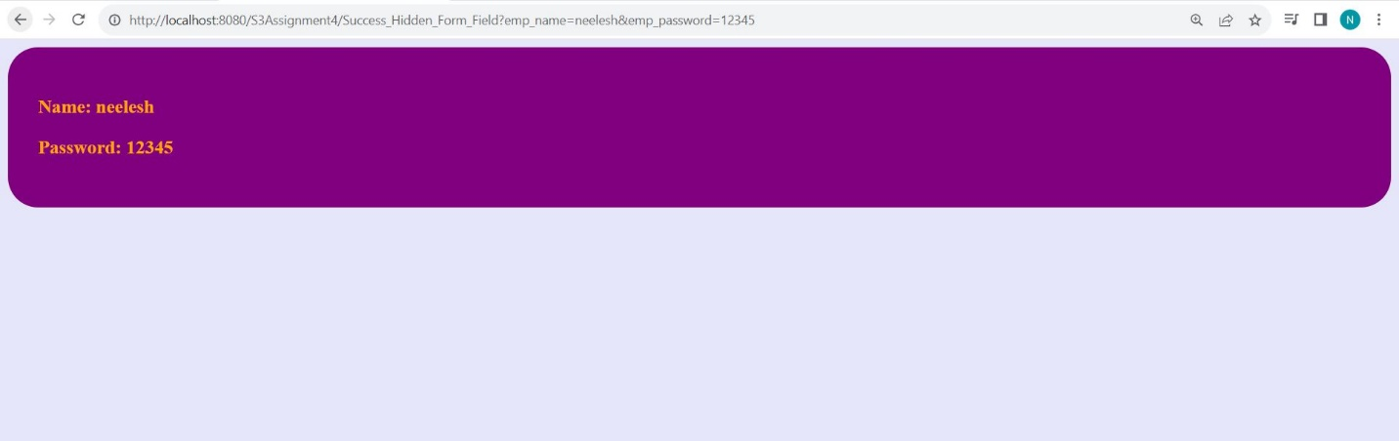

d) Display a success message on a new Page with the user name maintained in session using URL Rewriting. 20

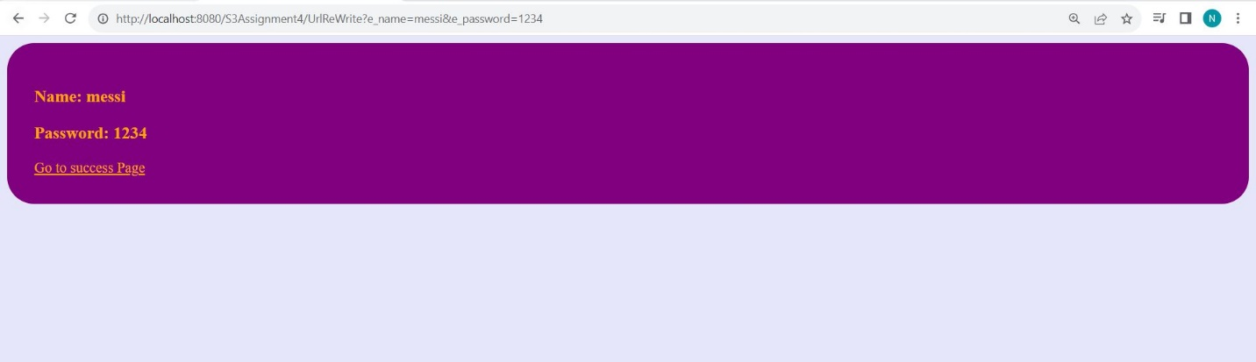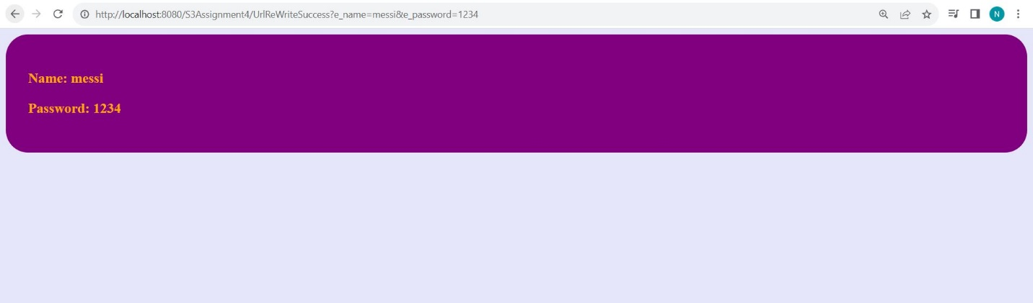

e) Display a success message on a new Page with the user name maintained in session using HTTPSession. 20

